Log in


See all Life
el Cul

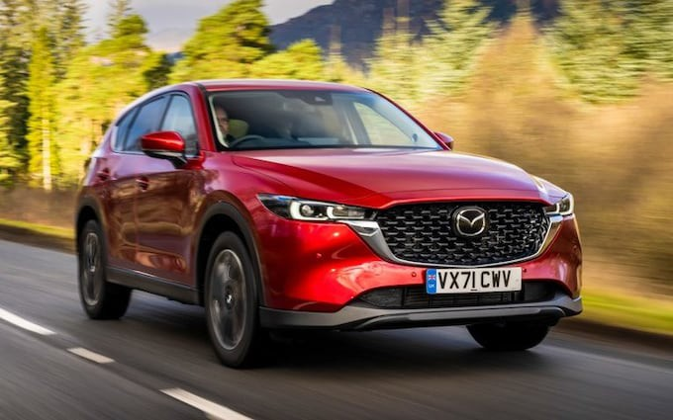
The Mazda CX-5 range starts from £28,145

R E V I E W

Mazda CX-5 review: the family-friendly SUV to put a smile on your face
4 / 5

Far from being dull and stodgy, this family car will delight keen drivers with its sharp dynamics – even with a diesel engine

By Alex Robbins, CONTRIBUTING EDITOR

9 February 2022 • 5:00am

t is drizzling in Scotland. The Trossachs skulk below a sky the colour and
texture of age-old pewter. And while the roads are not yet rivers, they are uniformly damp.
I

The Duke’s Pass beckons. This is not one of those great mountain roads whose name you’ll have heard spoken in hallowed tones by driving enthusiasts. To the
ă ă ăș n Pass in Romania, it is
Route Napoleon in southern France or the Transf g r a

but naught. It is not wide, nor forgiving; on each side of a strip of Tarmac barely
wide enough to fit two cars side-by-side lie deep, wheel-killing troughs, while on the insides of each bend are high kerbs designed to bounce you of.

Not a road you would want to mess around with too much, then. But there probably won’t be that much messing around – after all, this is a medium-sized SUV with a diesel engine and an automatic gearbox.

Were this any other diesel auto SUV, that is. But this one is a Mazda CX-5, built by the same people who brought you the nimble MX-5 roadster. It is, in short, actually rather handy for an SUV. So in fact, it’s not such a daft car to be in on this bit of road.

The question is, can the CX-5 still raise a smile, even here, in this weather? And, more importantly, when we’ve finished mucking about on the side of a Scottish hill, will it still work the way 99 per cent of its buyers will use it – as a sensible family hauler with which to tackle the daily grind?

Pros

Still great to drive

Smart, stylish interior with excellent switchgear Very well equipped, even in base form

Cons

Not as versatile as the best family SUVs

Ride can get fidgety on bigger wheels

Not very economical

Under the skin



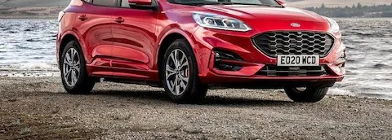

There’s more to this new CX-5 than initially meets the eye; yes, the cosmetic upgrades are fairly subtle and the interior has barely changed at all, save for a new infotainment system with a wider screen

Usually, you get the impression a midlife facelift is pretty light when a manufacturer resorts to highlighting things such as the addition of wireless charging (ooh) and traffic jam assistance for the adaptive cruise control (ahh) in the press kit.

But, in fact, there’s more to this new CX-5 than initially meets the eye; yes, the cosmetic upgrades are fairly subtle and the interior has barely changed at all, save for a new infotainment system with a wider screen. Under the skin, however, the chassis has been given a thorough going-over; 50 per cent of the suspension parts are new, while the bodyshell has been stifened in key areas.

There are two new models, too. The first is the quirkily named Newground, a sort-of vague stab at a more youthy-lifestyley model which, for reasons known only to itself, Mazda has seen fit to emphasise through the addition of a luminous yellow badge in the grille; inside, there are similarly violently-hued air vent bezels and matching upholstery, ahem, highlights.

The Newground can be had only with the 163bhp 2.0-litre petrol engine, which Mazda says is because it’s the most popular of the lot; the same goes for the Sport Black, which gets its silver bodywork trim pieces switched for (you guessed) gloss black, along with a red grille badge and red stitching inside.

These mainly cosmetic packages sit between the three core models in the line-
up: SE-L kicks of the range, and can be had with either the 2.0-litre petrol or a
2.2-litre diesel of 148bhp, though with dual-zone climate control, adaptive LED headlights and adaptive cruise control, it’s hardly a poverty-spec base model.

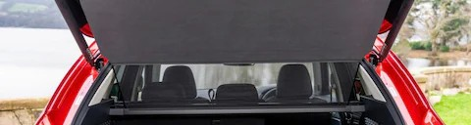

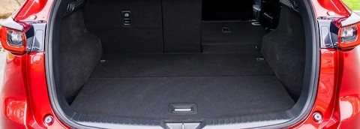

Inside the boot of the Mazda CX-5

The Sport we’re testing here then sits between the Newground and Sport Black, and adds leather upholstery, with heated front seats and a powered boot lid; it’s set to be the big seller of the range, and so gets the same engine choice as the SE-L, as well as a 182bhp version of the 2.2-litre diesel with an automatic gearbox and four-wheel drive as standard.

At the top of the range sits the GT Sport, which gets a glut of extra equipment, topped of with brown Nappa leather seats which are both heated and ventilated in the front, and heated in the back, as well as body-coloured bumper and wheel-arch extensions to set it apart. You can have this with either the 2.0- litre petrol or the more powerful diesel, or there’s a 191bhp 2.5-litre petrol, which comes exclusively with an auto and four-wheel drive.

All in, there are 20 flavours of this new model; clearly, over at Mazda at least, the rationalisation of trims and engines that has been so prevalent in the industry these past few years due to a scarcity of semiconductors is a thing of the past.

Diesel is still an option

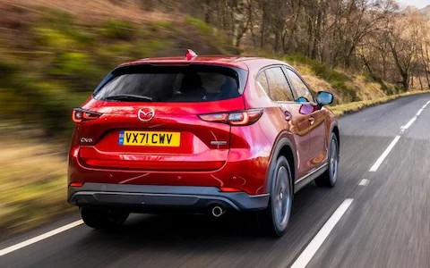

It’s worth noting here Mazda’s commitment to diesel; where other manufacturers are dropping the pariah of fuels as quickly as they can, Mazda is sticking with it

It’s worth noting here Mazda’s commitment to diesel; where other manufacturers are dropping the pariah of fuels as quickly as they can, Mazda is
sticking with it. Come to think of it, what more would you expect from a company that has bucked every automotive trend of the last few years?

You can admire this commitment to its principles, call it noble, even. But the trouble is, in the real world, the CX-5 simply isn’t all that fuel efficient. Even against its increasingly rare diesel rivals, its official consumption figure of
46.3mpg looks a little on the low side, while compared with the petrol hybrids
that are slowly but surely usurping them, the CX-5 starts to look positively thirsty.

Take the Ford Kuga hybrid, for example, which has an additional 40bhp or so to call on, yet despite this will also achieve about five miles more to the gallon; in the real world, away from the laboratory-based fuel tests, that disparity will only broaden, as the Kuga puts its regenerative braking to good use around town.

Long-legged cruiser



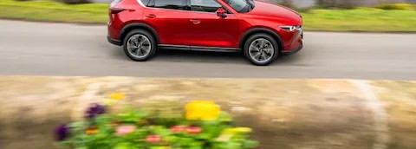

With the bigger wheels, the CX-5 is not uncomfortable, but it does feel tense; while it never actually jars through bigger bumps or potholes

Every version of the CX-5 sits on 19-inch wheels as standard, except for the SE- L, which probably makes it the model you’d want. With the bigger wheels, the CX-5 is not uncomfortable, but it does feel tense; while it never actually jars through bigger bumps or potholes, you can feel the texture of the road surface beneath you coming up through the chassis, and the car quivers as though it’s permanently ready and waiting for you to tip the steering wheel into a challenging complex of cambered B-road bends.

At speed, meanwhile, you get a little bit of mid-frequency white noise from the tyres, but the suspension relaxes enough to make the CX-5 a satisfyingly long- legged cruiser. The seats are comfortable, too, and after two hours ensconced behind the wheel, you can climb out still feeling pretty fresh and ache-free.

Internal affairs

The rest of the interior is just as lovely as ever. The Sport lacks the beautiful slivers of open-grain wood you get in the GT Sport model, but the plastics are all

high-quality and there’s a business-class feel to the tasteful design, the restrained strips of chrome and the tactile materials used throughout.

However, its rivals always were a bit more practical than the CX-5. Granted, there’s plenty of room for rear-seat occupants and the boot is a usable size but, at 510 litres, it isn’t the biggest in its class. Also, the rear seats don’t slide forward
a.uu ua.n..wc:u. u LU a.uuw yuu LU J.1.le1A.lJ.1J.1i.')'C 1u00a.0c i.')_l.JC1 c u yuu v ie; u11.1y a. v c.i y
small person or two to carry.

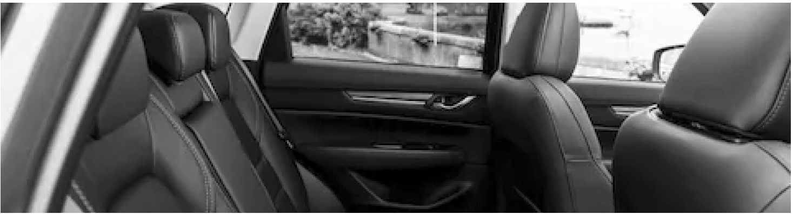

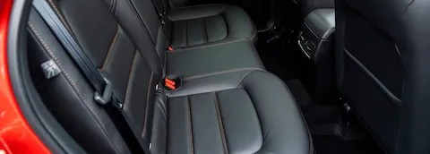

All three seat backs fold down individually. With the seats folded, the boot ﬂoor is ﬂat; there’s also a little bit of extra space in a hidden compartment beneath the boot ﬂoor

At least all three seat backs fold down individually. With the seats folded, the boot floor is flat; there’s also a little bit of extra space in a hidden compartment beneath the boot floor, although as this is a rather odd shape there’s a limit to how much of it you can actually use.

The 148bhp diesel of our test car is still our pick of the engine range. Yes, you can go for the 2.0-litre petrol instead, but based on a two-hour stint in one, I wouldn’t recommend it; in common with all modern Mazda petrols, it only really starts to deliver on the sort of performance its power figure promises if you hold it in gear and rev it to the red line. And while this is great fun on a winding Scottish mountain road, it’ll be rather less so on the school run or the motorway, when instant, low-down punch is much more useful.

If you really don’t want a diesel you might consider upgrading to the 2.5 petrol, but beware; it isn’t exactly over-endowed with low-end torque either and, with four-wheel drive and a slightly lethargic six-speed torque-converter automatic gearbox, you’ll find it goes through fuel like Argyll and Bute goes through single malt.
Interestingly, despite being the same basic gearbox, the six-speeder in our diesel felt much more lively – enough to make it a real alternative to the sweet- shifting, MX-5-esque six-speed manual if most of your driving is in town. You’d choose it over a Volkswagen Group DSG unit without much hesitation, too, so smoothly does it shift when left to its own devices.
Take control yourself and it responds almost instantly, changing as and when
you ask it rather than delaying shifts like the nannying units in some rivals do.

On the road



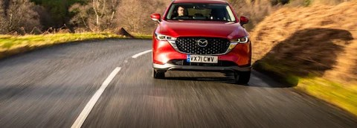

What the CX-5 does so well is to disguise its bulk. Pressing on, it feels more like a well sorted family hatchback – think Ford Focus – than a big SUV

With all of this in mind, it’s not such a hardship to be in this version of the CX-5 for my run up the Duke’s Pass. And by the time I reach the top I’m happy to be able to report that this is still, against the odds, a very satisfying car to drive.

What the CX-5 does so well is to disguise its bulk. Pressing on, it feels more like a well sorted family hatchback – think Ford Focus – than a big SUV. In other words, not overtly sporting, but responsive and agile, with plenty of feedback through the chassis, so that you can tell exactly what the car’s up to and thread your way through the next bend neatly.

The steering weights up nicely of-centre, and each turn of the wheel is met with a crisp response from the nose. It doesn’t dive into bends eagerly, but then you wouldn’t want it to, as that could unsettle the body. There’s not much in the way of lean, although the suspension isn’t rock-hard either; in fact, it’s perfectly set up to cushion mid-corner bumps and undulation changes.

In other words, you get the sense that Mazda’s engineers have thrown as much love at the suspension set-up of the CX-5 as they have at those of the brilliant 3

hatchback and MX-5 sports car – which, given the company’s commitment to
driving dynamics, they probably have.

The Telegraph verdict

Of course, in a big SUV, exciting handling must play second fiddle to more
p g
comfortable? Yes. Is it safe? Yes. Is it well equipped? Yes. Is it a pleasant place to be? Oh yes.

Is it practical? Well, for the most part, though some of its rivals are better in this regard. They’re also more easy to recommend if diesel is a no-no; what’s more, the CX-5’s lack of a plug-in hybrid (PHEV) option will deter many company car drivers.

But if you’re buying an SUV grudgingly, resentful of the fact it’ll take you away from the sweet-driving hatchbacks you’re used to buying, take a look at the CX-
5. Come rain or shine, it should put a smile on your face.

The facts

On test: Mazda CX-5 2.2 Skyactiv-D 150 Sport Automatic

Body style: five-door SUV On sale: now
How much? £34,145 on the road (range from £28,145) How fast? 124mph, 0-62mph in 10.7sec
How economical? 46.3mpg (WLTP Combined)

Engine & gearbox: 2,191cc four-cylinder diesel, six-speed automatic gearbox, front- wheel drive

Maximum power/torque: 148bhp/280lb ft CO2 emissions: 160g/km (tailpipe)
VED: £895 first year, then £155 Warranty: 3 years / 60,000 miles
Spare wheel as standard: No (not available)

The rivals

Volkswagen Tiguan 2.0 TDI 150 DSG Life

